**Lab7: Charging and Discharging of RC circuits**

**Objective:**

• Learning the use of Signal Generators and Oscilloscopes.

• Investigating the behavior of charging and discharging of RC circuits with changing Time Period, T of the input Square wave.

**List Of Equipment:**

1.Breadboard

2.Capacitor

3. Resistor (5k)

4. Oscilloscope.

5. AC power supply.

**Theory:**

**RC charging:** A resistor-capacitor circuit (RC Circuit) is an electrical circuit consisting of passive components like resistors and capacitors, driven by the current source or the voltage source.

τ = R x C

τ in seconds, where R is the value of the resistor in ohms and C is the value of the capacitor in Farads.

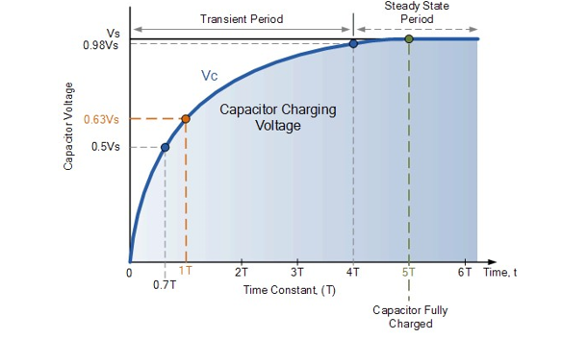

Voltage,Vc across the capacitor varies with time according to the formula:

*V(t)* = *V*o (1 – e–*t/RC*),

**RC Discharging:**

When the power supply becomes neutral, the capacitor will discharge itself reversely through the resistor.

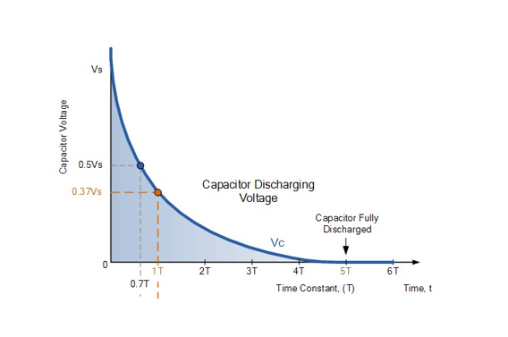

For a RC discharging circuit, the voltage across the capacitor ( Vc ) as a function of time during the discharge period is defined as:

*V(t)*  = *V*oe–*t/RC*

• Vc is the voltage across the capacitor

• Vs is the supply voltage

• t is the elapsed time since the removal of the supply voltage

• RC is the *time constant* of the RC discharging circuit

**Circuit Diagram:**

**Data and table:**

Here,

R=5k ohm

C=0.22 uF

Vin=10V

Time constant, 𝜏 =10RC

=(10*5000*0.22*10^-6)s

=1.1ms.

Time constant, 𝜏 =30RC

=(30*5000*0.22*10^-6)s

=3.3ms.

Again,

Frequency of input signal, f = 1/T

=90.91 Hz

Frequency of input signal, f = 1/T

=30.30 Hz

Frequency of input signal, f = 1/T

=285.71 Hz

**Question and Answer:**

2.Explain what is time constant, 𝜏.

Answer: The time constant, 𝜏 is the parameter characterizing the response to a step input of a first-order, linear time-invariant system. The time constant is the main characteristic unit of a first-order LTI system.

3. Theoretically calculate 𝜏 and compare with the measured value of 𝜏.

Answer: We can get the value of 𝜏 from the lab which is 2 ms, 1.8ms and 1.12 ms.

We know that,

𝜏= RC

For T = 10RC, Time constant, 𝜏 =10RC

=(10*5000*0.22*10^-6)s

=1.1ms.

For T = 30RC, Time constant, 𝜏 =30RC

=(30*5000*0.22*10^-6)s

=3.3ms.

So, 𝜏 isn’t the same for theoretically calculation and measured calculation.

4. Using the data table, explain in details the charging-discharging pattern for all the 3 cases.

Answer:

**Result analysis & Discussion:** In this experiment we learned about Charging and Discharging of RC circuits. For this experiment we were provided Capacitor,Resistor (5k), Oscilloscope, AC power supply. First ,we calculated the value of input frequency such that T = 10RC. Then we adjusted the frequency of the input signal to that calculated in part 1.Next we, Connected the Channel 1 of the oscilloscope to the input signal. Then we adjusted the input peak to peak value to 10v. Next we connected channel 2 of the oscilloscope with the capacitor.After that,we measured 𝜏, final output voltage of the capacitor Vc ,the time the capacitor charges up to Vc , the time the capacitor starts to discharge, the time the capacitor stops discharging from the oscilloscope.Then we calculated the input frequency such that T=30RC. Using the same procedure we calculated the input frequency such that T= 3.5ms (T<5RC). That was the end of our experiment.

**Table of Contributions**

**During the experiment in class:**

•1921079642 Mosroor Mofiz Arman: Building the Circuit

•2021646642 Sumit Kumar Kar and 2022655642 Nasim Anzum Promise: Checked whether all the circuits were built correctly or not and whether all the data were written carefully and accurately or not.

• 1831100642 Muhammad Raiyan Alam: Wrote data in Lab Manual and helped group members with the steps

**During Lab Report:**

• 2022655642 Nasim Anzum Promise: Wrote objective, theory part and Discussion.

• 2021646642 Sumit Kumar Kar: Drew Multisim

• 1921079642 Mosroor Mofiz Arman: Solved Questions and Answers